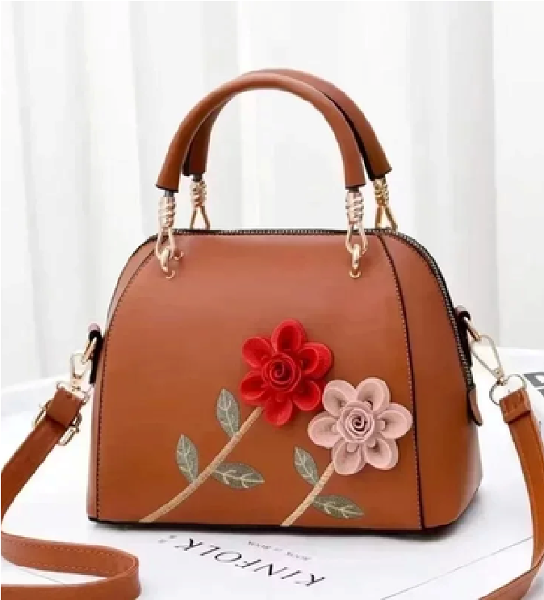
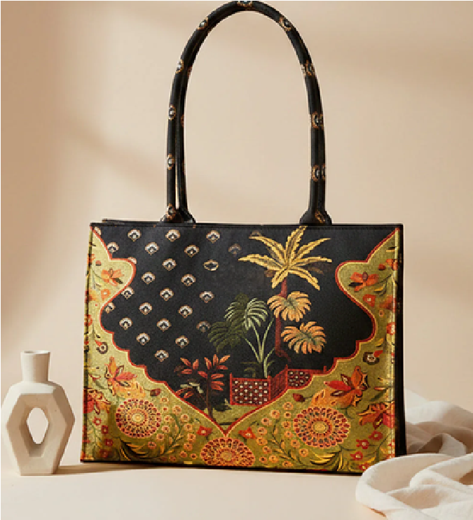
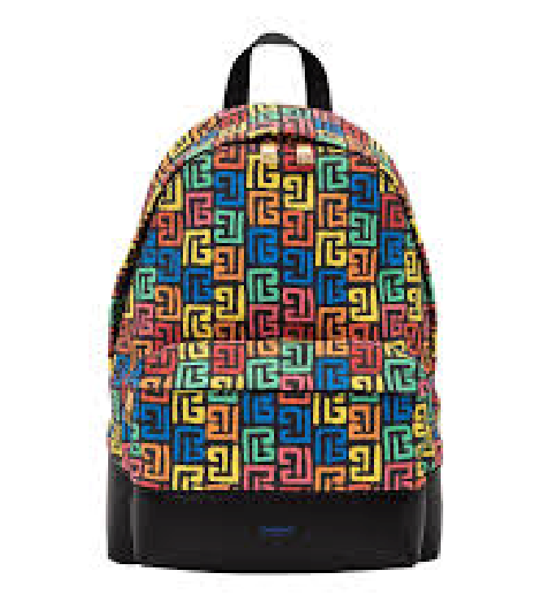
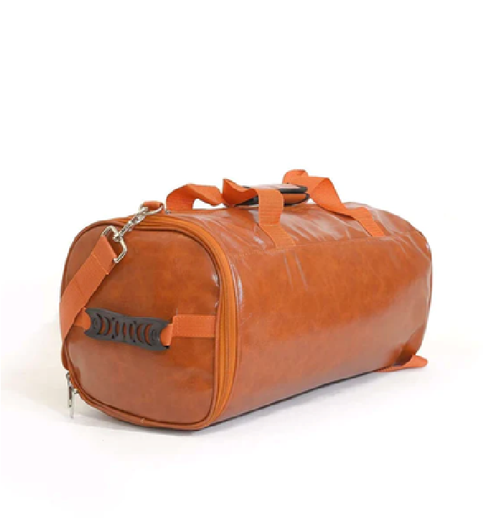

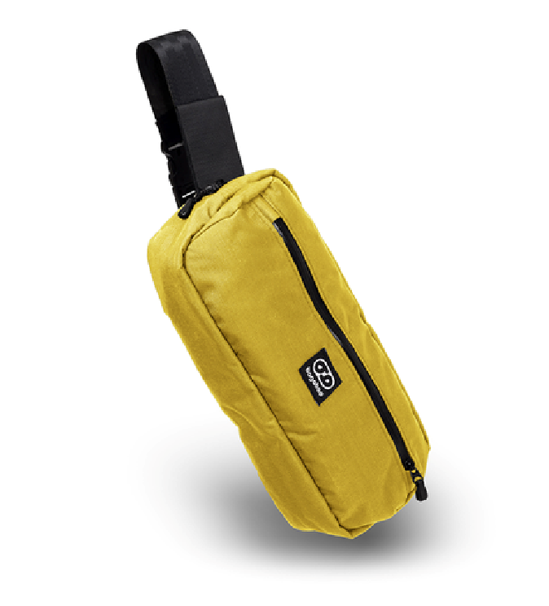
BAGBAG
Catalogue
BagBag
www.bagbagstore.com
Formal Clutch
Rs. 4000
Elegant Handbag
Rs. 2500
Gym Slingbag
Rs. 1200
Trendy Soft Totebag
Rs. 3500
Coolbell Backpack
Rs. 1800
Duffel Bag
Rs. 2000
2026

